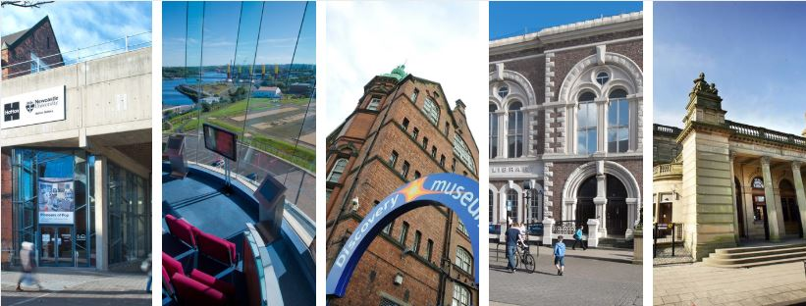

Introduction to Tyne & Wear Archives & Museums (TWAM)

- 1974 Tyne and Wear Museums formed under Tyne and Wear County Council
- 1986 Tyne and Wear County Council dissolved
- 2009 TWM becomes Tyne & Wear Archives & Museums (TWAM)
- 2010 Tyne & Wear Archives & Museums TWAMDT Development Trust created
- 2018 Tyne & Wear Archives & Museums TWAM Enterprises formed

Tyne & Wear Archives & Museums (TWAM) is a large and successful archive and museums service which receives 1.3 million visits per annum to the nine venues and to the archives for Tyne and Wear. TWAM manages these archives and museums on behalf of four local authorities (Gateshead, Newcastle, North Tyneside and South Tyneside) and Newcastle University.

The relationship between the four local authority partners is set out in a 10 year Joint Agreement which runs until 2027. The relationship with Newcastle University in respect of the Great North Museum site is the subject of a separate agreement between Newcastle City Council (as lead authority for TWAM) and the University. Sunderland City Council is a partner in respect of the Joint Archive Service and TWAM provides some specialist museum services to Sunderland Museums, funded by Arts Council and some services including exhibition design on a commercial basis.

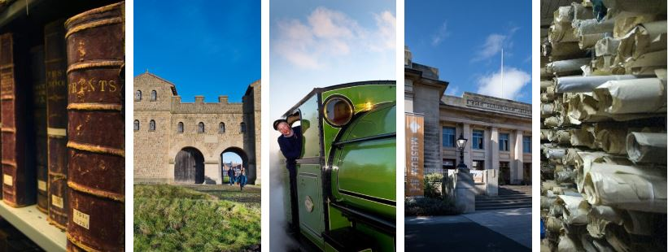
Tyne & Wear Archives & Museums is responsible for 9 museums, galleries & sites:

- Arbeia South Shields Roman Fort (UNESCO World Heritage Site)
Arbeia is a large Roman fort in South Shields, built in 160 AD. Arbeia guarded the main sea route to Hadrian's Wall. It was a key garrison and military supply base and is an important part of the history of Roman Britain with a rich collection and detailed reconstructions.

- Discovery Museum
Housed in the Co-operative Wholesale Society building, Blandford House which was transformed into a museum in 1978 and re-launched as Discovery Museum in 1993. Its collection tells the story of Tyneside through the people, industries and inventions that have changed the world.

- The Great North Museum
Built in 1884 as a natural history museum to house the collections of the Natural History Society of Northumbria. Noted ornithologist and taxidermist John Hancock was instrumental in establishing the museum and donated his prolific collection of British birds. When he died in 1890 the museum was renamed the Hancock Museum and is managed on behalf of Newcastle University.

- Hatton Gallery
Founded in 1925 and named in honour of Newcastle University’s Professor Richard Hatton, the Hatton Gallery has recently completed a £3.8 million redevelopment. Hatton Gallery stages modern and contemporary art exhibitions and events including talks and family activities.

- Laing Art Gallery
Founded in 1901, by the philanthropic vision and donation of Alexander Laing, the gallery today is home to an internationally regarded collection of art, including important paintings by John Martin, Paul Gauguin, Sir Edward Burne-Jones and Laura Knight.

- Segedunum Roman Fort (UNESCO World Heritage Site)
In AD122 the Emperor Hadrian ordered the building of what we now call Hadrian’s Wall. Segedunum, meaning ‘Strong Fort’, was built to guard the eastern end of the Wall, housed 600 Roman soldiers and stood for almost 300 years. A highlight is the nine storey high viewing tower.

- Shipley Art Gallery
The Shipley Art Gallery opened in 1917 with a collection of 504 paintings bequeathed by local solicitor Joseph Shipley. The collection now includes nearly 800 paintings and works on paper, contemporary craft and decorative art including ‘Christ Washing the Disciples' Feet by Jacopo Tintoretto and ‘The Blaydon Races’ by William C Irving as well as being used by community groups.

- South Shields Museum & Art Gallery
The museum situated in the centre of South Shields, tells the story of the borough's social, industrial and maritime history from 4,000 years ago to the present day through a range of displays, exhibitions and nationally significant works of art.

- Stephenson Railway Museum
George and Robert Stephenson spent 20 years in North Tyneside developing their pioneering ideas which helped spread railways and locomotives around the world. Today the Museum celebrates their achievement and holds a collection of working and stationary trains as well as exhibits.

Tyne & Wear Archives & Museums also facilitates and coordinates:

- Tyne & Wear Archives
Based in Discovery Museum, Tyne & Wear Archives is home to thousands of documents, relating to businesses, individuals and organisations, housed on 14km of shelving, relating to the five local authority areas of Newcastle, Sunderland, Gateshead, North Tyneside and South Tyneside.

- The Late Shows
Since its inception in 2007 The Late Shows have grown considerably in size. In the first year, 14 venues took part: this risen to over 60, the event now welcomes between 30-40,000 visits across the weekend in May each year. It will take place over 17 and 18 May in 2019.

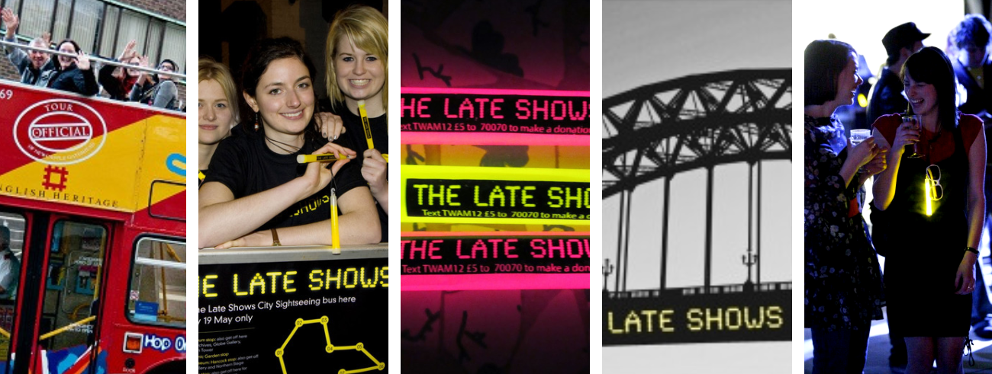

On behalf of the Arts Council England, TWAM also manages:

- Museum Development North East
TWAM is one of nine regional providers which form a national Museum Development network, providing tailored opportunities for participation in schemes, training, grants programmes and networks based on an informed understanding of the context and needs of museums in their area.

- Culture Bridge North East
The Arts Council England funds 10 Bridges across England, all of which are tasked with the strategic development of arts and cultural education by, with and for children and young people.

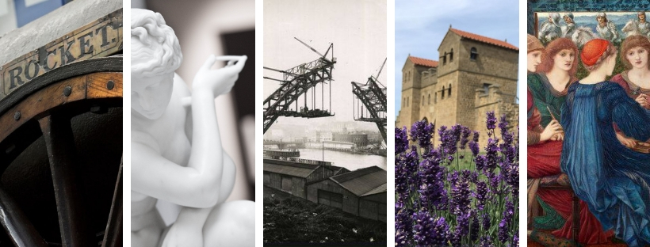
Who We Are | The Tyne & Wear Archives & Museums Development Trust (TWAMDT)

The Tyne & Wear Archives & Museums Development Trust was established on 1 December 2010 and is made up of a board of trustees supported by its Chair, Peter Judge, TWAM Director Iain Watson, Head of Finance and Governance Jackie Reynolds, the Development Department and the TWAM administration team.

The Trust is currently focused on supporting the Development Department in establishing dynamic and new ways to generate much needed income, for both day to day activities and future exhibitions, activities and capital projects. These income streams include philanthropic donations, exhibition or programme sponsorship and encouraging businesses and individuals to support TWAM as we look towards the future of museums and the needs of our 1.3 million visitors.

The TWAM Development Trust is registered with the Charity Commission under charity number 1137867 and registered with the Fundraising Regulator. This means we are committed to ensuring that our fundraising is legal, open, honest and respectful.

Objectives of the Trust:

- To advance the education of the public (particularly, but not limited to, those within the metropolitan county of Tyne & Wear) by encouraging them to participate in and contribute to the activities of an archive and museum service managed by Tyne & Wear Archives and Museums (TWAM) and to value it for the positive impact that it makes upon their lives;
- To advance art, heritage, culture and science by supporting TWAM to establish and maintain a world class archive and museum service that is accessible and enlightening;
- To contribute to the advancement of civic responsibility and good citizenship by supporting TWAM to help to equip people with the capacity to understand and operate successfully in society; and such other charitable purpose beneficial to the community consistent with the objectives above as the trustees shall in their absolute discretion determine.

The Trust carries out its objectives by supporting TWAM in generating income from individual supporters, business partnerships, sponsorships and trust and foundations to support a wide variety of museum activities including:

- Exhibitions and displays
- Capital improvements
- Cataloguing
- Acquiring objects for the collection
- Conservation and restoration work
- Learning programmes & Outreach projects
- Digital initiatives

By supporting activities like these, the Trust is able to help TWAM achieve its strategic vision of ensuring everyone has access to museum and archive provision.

By becoming a trustee you will be joining a wide network of individuals, businesses, partners and connections who are passionate about promoting the region’s art, heritage and culture while working to support TWAM to ensure it can continue to deliver high quality exhibitions, experiences and opportunities for its 1.3 million visitors every year.
Trustees:
Peter Judge MBE, Chair 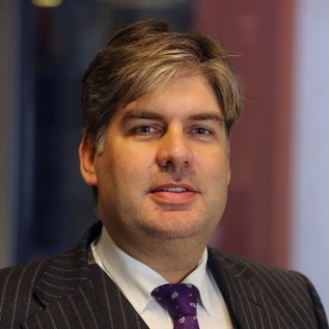 | Peter has been Chair of the TWAM Development Trust since 2017. Peter is a lawyer with a wealth of leadership experience gained in complex organisations. He holds an number of non-executive appointments in addition to his current in-house role as a Chief Officer of the North East Local Enterprise  Partnership. Except for his recent service as Attorney General of the British Overseas Territories of the Falkland Islands and South Georgia and the South Sandwich Islands, Peter has lived and worked in the North East since he graduated. Peter was named UK In-House Lawyer of the Year by The Lawyer Magazine in 2010 and was appointed MBE for services to Economic Development and North East England in 2012.
James Garbutt, Vice Chair | James is a founding director of Rathbone Investment Management’s Newcastle Office. He specialises in the management of investments for charities, pension schemes and trusts and he has more than 20 years of industry experience. James has managed assets for charities throughout his career but specialised in the sector since joining UBS from Gerrard Investment Management in 2005. Originally from Newcastle, James has worked here throughout his career. James is married and has 2 young children, he enjoys an active lifestyle, playing golf, running, cycling, skiing and water sports. He also enjoys the arts and has an interest in film and theatre.
Cllr Kim McGuiness | Kim was first elected to Newcastle City Council as a Labour councillor in May 2015 and was appointed to her role as cabinet member in June 2016. She has taken a lead role in a variety of sporting and cultural projects, helping secure prestigious sporting events for the city and overseeing efforts for the Great Exhibition of the North. Kim is a trustee of Sport Newcastle and the Heart of the City Partnership (Newcastle Castle). Kim was born and brought up in Newcastle upon Tyne, attended Newcastle University and graduated in 2006. Kim has worked in private sector finance, universities and more recently at a senior level in educational and environmental charities.
Andrew Miller  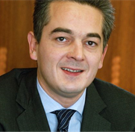 | Whilst at Gerrard Ltd, Andrew’s organisation benefitted from Art in the Workplace, a loans scheme which saw art from the TWAM collection in his workplace. Andrew has worked with TWAM for a number of years. Andrew has recently joined Julius Baer as senior relationship manager bringing over 25 years of experience from Barclays Wealth. Andrew will be covering the North East region with a particular focus on Newcastle and the surrounding area.
Ammar Mirza  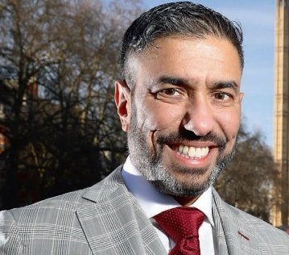 | Ammar has helped to establish several hundred businesses in the North East. He is Founder and Chairman of Asian Business Connexions and President of the Federation of Asian Business alongside being a Fellow of the Institute of Leadership & Management (FInstLM), and Royal Society of Arts (FRSA). He has a particular interest in enterprise education as Chair of Governors of a Primary School, Chair of the Progression Forum and a visiting Professor of Practice at Newcastle University, and having helped launch the Primary Inspiration through Enterprise (PIE) Project Charity. Ammar is the North East LEP Board’s local SME representative. Within TWAM Ammar is very involved in NE Culture Bridge.
Charlotte Windebank | Charlotte works with businesses looking to increase their profile and engage in innovative and meaningful CSR opportunities. She also works with professionals, start-ups and young people to develop essential business skills, get work and ensure meaningful connections are made within the business community. FIRST is a network of services dedicated to building entrepreneurial skill sets in start-ups and young people. She has managed over 70 networking events over the last 3 years and delivers workshops for education, corporates, charities and start-ups to boast confidence and energise ‘can do’ attitudes when it comes to business development.
Christine Holland | Christine is the owner of Holland PR and Marketing Limited.  Christine is a North East Chamber of Commerce Council Member, advising on policy, and a long-established member of the Institute of Public Relations. In this role she has been employer representative for CASE (Advancing Skills and Employability) and employer representative for the Environmental Partnership, Newcastle Plan. She was a founder member of Help the Aged (North Tyne Branch).

Key TWAM Staff

Iain Watson,  Director | Jackie Reynolds,  Head of Finance, Governance & Resources | Sophia Stovall,  Development Department
Iain has overall responsibility for TWAM's commitment to deliver a world class service which is innovative, imaginative, creative, inclusive, secure and sustainable. Iain is ultimately accountable to the Archives and Museums Strategic Board and to the funding stakeholders of the Joint Service. | Jackie is responsible for the efficient management and administration of TWAM's financial and people resources in particular with regard to ensuring these resources are used effectively and efficiently to deliver the Organisational Plan approved by the Strategic Board. | Sophia joined TWAM in August 2018 to lead the new Development Department, supported by the Heritage Lottery Fund. Sophia is responsible for a team of 5, who together are tasked with tripling philanthropic income by 2022 through a number of new and refreshed mechanisms.

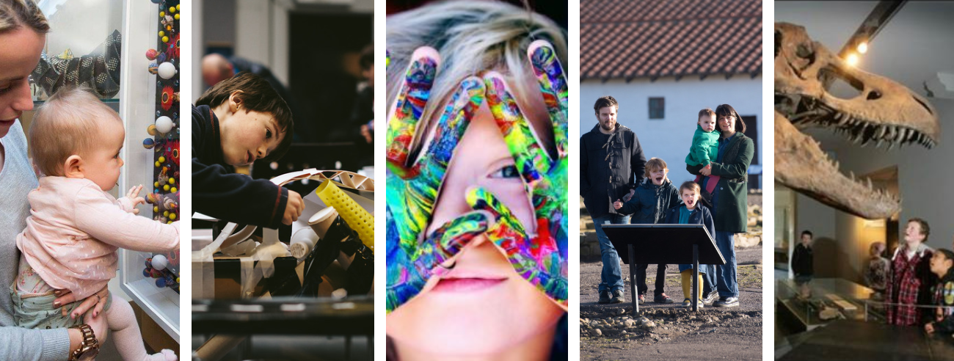
A Very Niche Network

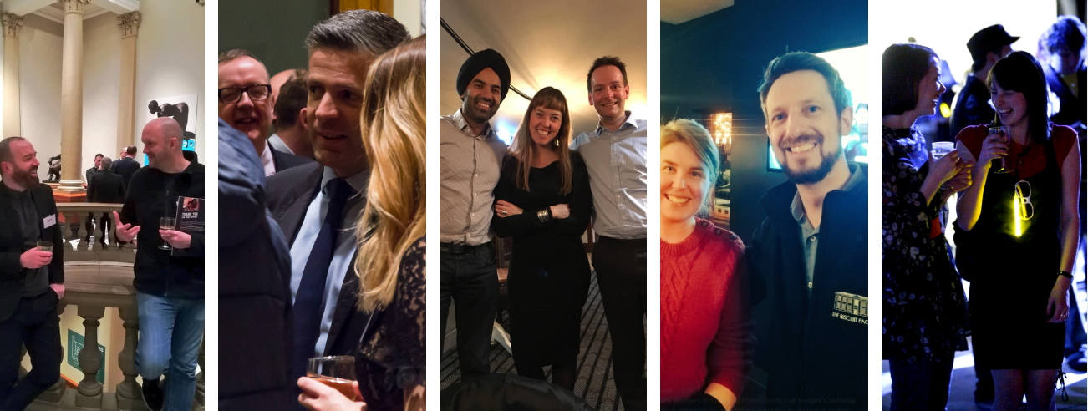

Trustees offer their invaluable insight, experience and time to support TWAM and join a dynamic and dedicated group of individuals, businesses, partners and institutions who together help support TWAM’s mission, vision and values.

Each trustee supports the endeavours and activity of the Trust and Development Department. This includes sharing expertise, offering in-kind opportunities, sector insights or access to networks, facilitating or brokering partnerships or supporting TWAM with a personal donation or gift.

TWAM has a wide network of local, regional, national and international partnerships across the educational, community, business and cultural sectors. Below are some of the much valued business partners who support our programme.

This is an area of activity that trustees play a key part in, by supporting the Development Department in making connections, introductions & raising the profile of TWAMDT across the business sector in the region and nationally. We are extremely fortunate to work with a number of businesses & partners from across the region and are keen to build on our existing business support and partnerships.

A word from our Partners, Supporters & Friends

Baldwin’s Accountants, as organisers of the Sunderland Professional’s Network are delighted to support and promote the fantastic work of TWAM. We’re passionate about working with organisations like TWAM to help preserve and showcase the North East’s unique heritage and culture.
Brian Logan, Baldwin’s Accountants

TWAM holds the key to where the people of the region can walk into their very own heritage & culture and explore. The organisation is primed to be the centre of engagement and immersive experiences for the North East, which is why I am keen to work with the various venues and explore how we can democratise and share cultural experiences of the region, for all.
Dave Black, Pitch Black Productions

TWAM is a vital part of the arts and culture offer within the city. Not only does it provide unrivalled sources of information for our academics, but there is an abundance of free offers on for visitors to the city which is truly inclusive for all – families, young people and older citizens. Furthermore, the attractions are excellent and attract similar, often world-class exhibits. This all contributes massively to our economic prosperity as a city and so we are always keen to support and promote TWAM.
Louise Liddle, Business Network Manager, Newcastle NE1
It is an honour and a privilege to be both a trustee and supporter of TWAM Development Trust. TWAM sits at the heart of our region’s cultural landscape and is rightly proud of the contribution it makes to the creation and promotion of world class culture in the North-East of England. I believe that the work that TWAM does is of huge importance to our community and I am delighted and enthused to be working with a hugely talented group as we look to the future with ambitious goals that will help us further transform our cultural landscape and identity.
James Garbutt, Trustee and Benefactor

TWAM Funding

TWAM is funded by a number of key stakeholders:
- Gateshead, Newcastle, North Tyneside, South Tyneside and Sunderland Councils
- Newcastle University
- The Ministry of Defence (for a regimental museum held within Discovery Museum)
- Arts Council of England

TWAM | Income 2019/20

TWAM | Expenditure 2019/20

Looking to the future
TWAMDT currently provides 5% of TWAM’s overall income but with the new Development Team in place and the support of trustees it is intended to treble this in the next three years.
We hope that you can help us on that journey.
Whilst investment from four local authorities, Newcastle University and the Arts Council provides the key core support for TWAM, there is a need to increase our voluntary income to sustain and support the future of TWAM. The priority is to develop fundraised income which can support TWAM’s day to day mission critical work. This amounted to £320,000 in 2018/19 and is planned to grow to £780,000 by 2022. This income supports crucial activity across the organisation, and without it many of our learning programmes, our activity with hard to reach groups and our exhibitions and events just wouldn’t happen.
Outside these income targets the TWAMDT and the Development Department also fundraise to support special projects – whether large projects like the £3.2m redevelopment of the Hatton Gallery completed in 2017 or small projects, like a Commemoration of the 100th anniversary of Peace Day in summer 2019 with Newcastle schools.
Trustees are key supporters and advocates for TWAM; they support the Director and the Development Department by advising on activity and potential prospects; they use their networks and they attend events to cultivate supporters on behalf of TWAM. Being a trustee is also an opportunity to have great fun and an opportunity to engage with the TWAM family – 9 museums, a regional archive and 1.3m visitors!
Our trustees help us in a number of ways, some recent examples include:
- Advising on key areas of activity, such as Exhibition Tax
- Signposting and making referrals, which have led to sponsorship & individual donations
- Offering information as part of due diligence research to ensure ethical partnerships
- Supporting through personal gifts and advocacy
- Networking on behalf of TWAMDT
- Providing feedback, challenging decision making and being responsive to needs
Why TWAMDT? Why now?

This is an exciting time to join TWAMDT, with a new Development Team in place and vision for the future new trustees, you can make a real difference and help ensure one of the nation’s largest facilitators of art, culture & heritage continues to inspire conversations and experience rooted in our shared history and collections.

TWAM has a strong reputation for innovative thinking and for the quality of access, inclusion and learning work and is increasingly recognised for its entrepreneurial approach, but we cannot do this alone and rely on the support of many people, organisations and businesses to deliver our award winning programmes, exhibitions and events.

Here are a few highlights of recent, current & upcoming activity which have made it to the regional and national press:

- David Olusoga, BBC Two, A House Through Time was able to undertake research by accessing Tyne & Wear Archives, housed in the Discovery Museum, part of TWAM.
- Hartwig Fischer, Director of the British Museum will be visiting the region as a guest of TWAM in May 2019. The British Museum is one of TWAM’s many strategic partners.
- Return of Rocket, part of the Great Exhibition of the North, saw thousands of visitors over the summer of 2018 alongside a strong programme of exhibitions and events across TWAM including Enchanted Garden at the Laing Art Gallery and Which Way North at the Great North Museum: Hancock. All of which helped to increase the average donation per visitor.
- Bob Olley, a local South Shields artist was the star of King Coal, the summer exhibition at South Shields Museum and Art Gallery in 2018. The paintings were inspired by Bob’s career as a miner at Whitburn Colliery and his love of the region. Bob also donated 23 paintings and donated a painting to raffle, the proceeds of which went towards South Shields Museum and Art Gallery.
- Laing Art Gallery, Showcasing the collections of the region through Touring Exhibitions including a recent tour of Sir Edward Burne-Jones’s Laus Veneris, 1873-1878 which was the star piece in Tate Britain’s recent exhibition.
- TWAM’s Spring/Summer Programme 2019 includes:
  - Whistler: Nature, The Laing Art Gallery, 30 March – 16 June,
  - Glitter-Arty Party, Late Shows 2019 Launch, Biscuit Factory, 16 May 2019
  - The Late Shows, venues across Newcastle, Gateshead and Ouseburn, 17 -18 May
  - Dippy on Tour, The Great North Museum, 18 May – 6 October,
  - Charles Dickens, South Shields Museum and Art Gallery, 11 May – 14 September
  - Lego, The Discovery Museum, dates throughout Summer
  - 10th Birthday Party, The Great North Museum, 23 May – Celebrating 10 years since the museum’s £26million redevelopment when it merged with the Museum of Antiquities and the Shefton Museum
  - More than a Game football exhibition, South Shields Museum and Art Gallery, 15 June- 12 October
  - Durham Business Group Business Breakfast, The Great North Museum, 21 May
  - Women of Tyneside Festival Finale, Discovery Museum, 14 June

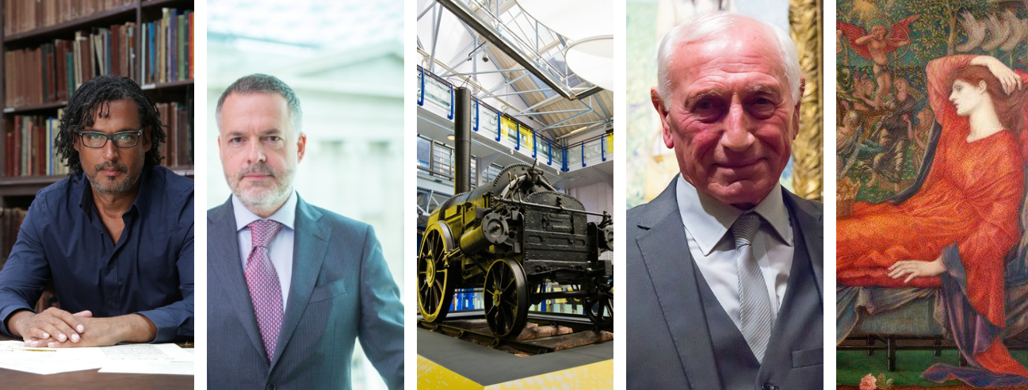
Trustee Role Specification

TWAMDT is looking for three new Trustees to join the Board of TWAMDT.

All trustees are expected to demonstrate:
- A love of art, culture and heritage and a commitment to TWAM’s strategic plan
- An understanding of the importance to TWAM & TWAMDT of fundraising and a commitment, as a leader of TWAMDT, to work with the Development Team to contribute to the delivery of the trust’s fundraising ambitions.
- Excellent judgement, ability to contribute to Board discussions, good communication skills and able to represent and advocate for TWAMDT.
- The ability to work collaboratively with other trustees and key members of TWAM staff.
- That they share TWAM’s commitment to diversity and equality

Remuneration  Location  Commitment  Closing Date | The roles are not remunerated but reasonable travel expenses will be paid.  Newcastle, Gateshead, North Tyneside & South Tyneside  4 board meetings per year, plus other events and meetings throughout the year as deemed appropriate.  Friday 24 May 2019

Interviews to be held on Monday 10 June & Monday 17 June between 10am and 2pm

We actively want to ensure that our Board is as diverse and representative of the population of the North East as possible and would welcome applications from all sectors of the community.

If you are interested in becoming a Trustee of the Tyne & Wear Archive & Museums Development Trust please submit a CV and covering letter explaining why you are interested and why you think you would be a valuable trustee. Please email your CV, covering letter and equality monitoring form to HRRecruitment@twmuseums.org.uk

If you wish to discuss this opportunity beforehand please do get in touch, we would love to hear from you:

Iain Watson, Director, TWAM
E: Iain.Watson@twmuseums.org.uk
T: 0191 277 2276

Peter Judge, Chair, TWAM Development Trust
E: Peter.Judge@nelep.co.uk

Sophia Stovall, Development Department TWAM
E: Sophia.Stovall@twmuseums.org.uk
T: 0191 277 2261

